The Uneven Climb of Low-Carbon Energy
In 1965, just over 6% of the world’s primary energy came from low carbon sources - mainly hydropower, nuclear, and, more recently, wind and solar. By 2024, that share has climbed to nearly 19%. The rise is real, but the pace has been painfully slow. Six decades of progress have tripled the share, yet fossil fuels still provide more than four fifths of the global supply. To understand this journey, we must explore the reasons behind the shifts, the lessons they reveal, and the choices they demand.
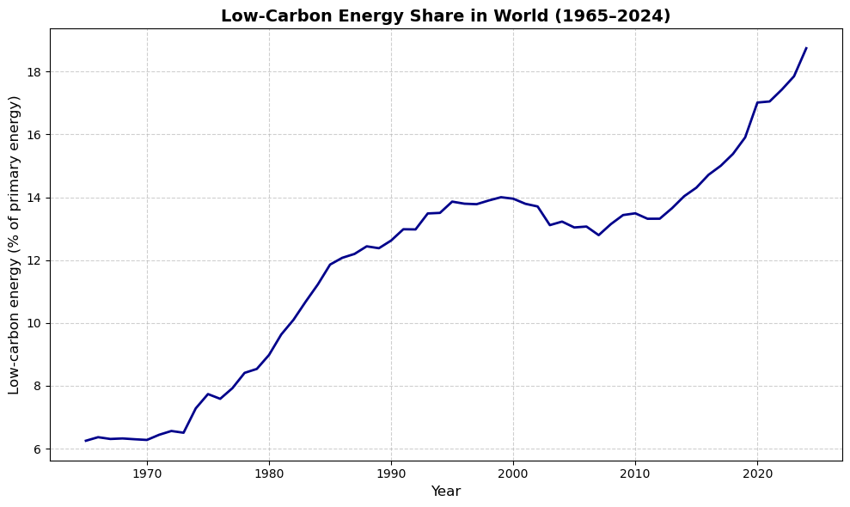
The early decades carried momentum. Massive hydropower projects in South America, Canada, and Asia pushed the global share higher. At the same time, nuclear power rolled out across Europe and North America. Together, these shifts lifted low-carbon energy into double digits by the 1980s. But momentum faltered soon after. Cheap coal and oil regained dominance, with crude oil prices collapsing from about $34 a barrel in 1980 to under $10 by 1986, while coal power was typically less than half the cost of nuclear per kilowatt-hour, and early renewables were many times more expensive. Political resistance to nuclear also hardened after the Chernobyl disaster in 1986, when a reactor explosion in Ukraine spread radioactive fallout across Europe. From the late 1980s through the early 2000s, the global low-carbon share stagnated between 13 and 14%. This stall was not due to technological limits but to political hesitation, short-sighted economic policies, and chronic underinvestment.
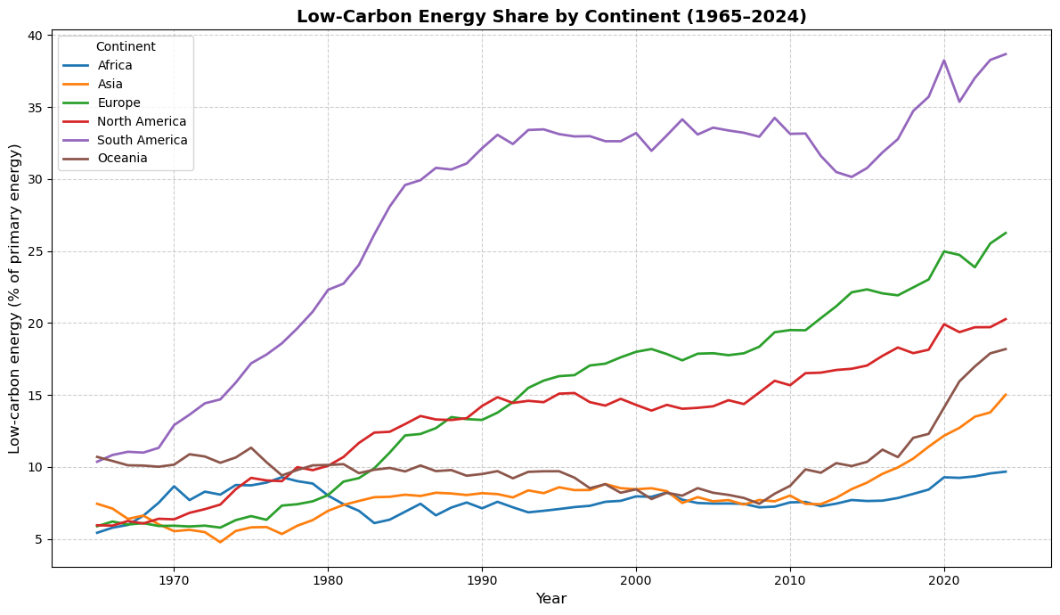
The revival came in the 2010s, as the cost of solar and wind fell dramatically, and supportive policies spread. Europe advanced steadily, surpassing 25% in recent years. South America extended its hydropower leadership to nearly 40%. Oceania, long stagnant, surged toward 18% thanks to Australia’s solar boom. North America, stuck around 15% for decades, is now above 20%, led by Canada’s hydro and U.S. renewables. Asia, despite building the most renewable capacity in absolute terms, still lingers near 15% because its fossil fuel consumption has grown even faster. Africa, despite vast solar and hydro resources, remains under 10%, held back by structural and financial barriers.
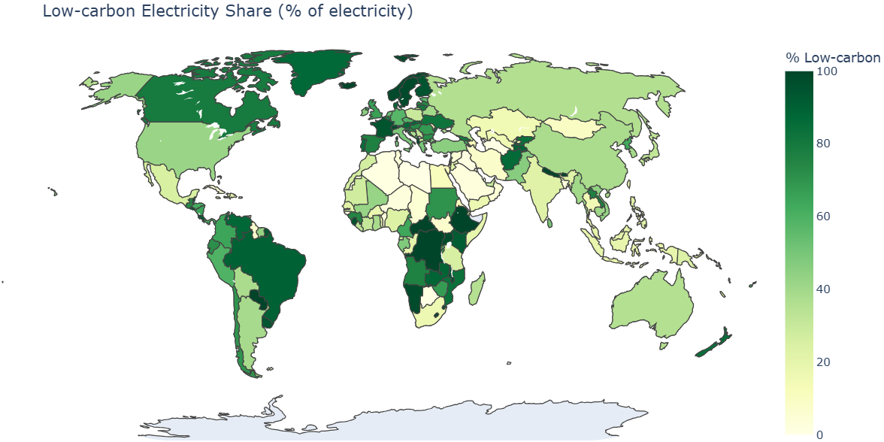
The uneven progress highlights key truths. Geography matters, but politics matters more. Where policies persisted across decades, such as Europe’s renewable directives and Brazil’s hydro planning, shares rose. Where politics wavered or investment failed, such as North America’s reversals and Africa’s financing gaps, progress stalled. And where fossil fuels remained cheap and abundant, as in Asia, clean energy gains were diluted.
The lessons are clear. First, technology is not the barrier anymore - renewables are now cheap and can grow quickly. Second, energy transitions need steady, long-term support, because stop-start policies slow progress. Third, fairness matters. Without better global finance, Africa and other developing regions will struggle to join the transition, even though they have huge potential.
The way forward follows directly. The world needs to speed up investment: build renewables three times faster, double grid capacity, and create stable policies that survive changes in politics. Fossil fuel subsidies must end, carbon pricing must grow, and climate finance must be restructured to give the Global South access to clean energy. Asia, as the world’s industrial hub, must not only build renewables but also phase out coal more quickly. North America must strengthen its commitments so they cannot be undone. And Europe and South America must stay on course, showing how consistent policy delivers results.
From 6% in 1965 to nearly 19% today, the world has shown that change is possible, but hesitation has been costly. The future now depends not on whether we can expand low carbon energy, but whether we have the resolve to make it the foundation of our economies before time runs out.

